Sentencing guidelines coming into force today

The Sentencing Council Guideline for ‘Health and safety, corporate manslaughter and food safety and hygiene offences’ comes in to force today. It will have a significant impact on the sentencing of offences and will apply to any case heard on or after today, irrespective of when the offence was committed.
The detail to the Guideline is set out in the article, but the headlines are as follows:
- Levels of sentencing for all relevant offences are likely to increase significantly;
- Turnover of organisations will be used as a determinant of size, and therefore level of punishment; and
- Decisions around levels of ‘harm’ and ‘culpability’ will be crucial to determining the applicable sanction.

The Sentencing Council Guideline for ‘Health and safety, corporate manslaughter and food safety and hygiene offences’ comes in to force today. It will have a significant impact on the sentencing of offences and will apply to any case heard on or after today, irrespective of when the offence was committed.
The detail to the Guideline is set out below, but the headlines are as follows:
- Levels of sentencing for all relevant offences are likely to increase significantly;
- Turnover of organisations will be used as a determinant of size, and therefore level of punishment; and
- Decisions around levels of ‘harm’ and ‘culpability’ will be crucial to determining the applicable sanction.
Health and safety offences - Organisations
The Guideline is based on the concept that ‘culpability’ and ‘harm’ are used to determine the level of fine, cross-referenced against the size of the Defendant organisation.
The measure of ‘culpability’ varies from ‘low’, where failings are minor and not systemic, to ‘very high’, where there has been a deliberate breach or flagrant disregard for the law. The level of ‘harm’ is based upon the risk of harm created by the offence, which is then exacerbated if actualharm has occurred.
Once the ‘culpability’ and ‘harm’ categories are established, the turnover of the organisation will be used to allocate a particular sentencing matrix. There are different matrices depending on the size of the organisation:
- Micro – Turnover not more than £2 million
- Small – Turnover between £2 and £10 million
- Medium – Turnover between £10 and £50 million
- Large – Turnover over £50 million
The matrix for large organisations is below:
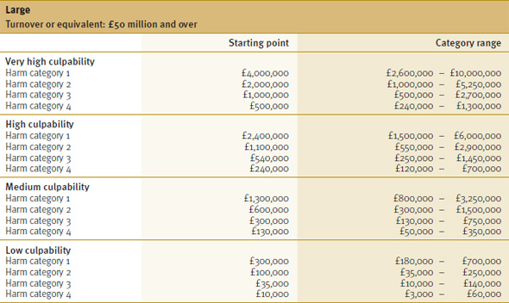
Provision is made for ‘very large’ organisations, with the Guideline stating that it may be necessary to move outside of the stated ranges. Unfortunately, no further guidance is given on how those calculations should be conducted.
Once the matrix has been used to determine the fine range, it will then be for the Court to engage in the normal sentencing exercise and follow the following process:
- Consider any mitigating and aggravating features of the case, as listed in the Guideline;
- Ensure that the fine is proportionate to the means of the offender;
- Consider other factors that may warrant adjustment of the fine, such as the impact of any fine on the local economy; and
- Apply a reduction for a guilty plea (where appropriate).
Whilst the figures used within the Guideline provide some clarity to the sentencing process, the above four stages still maintain a level of unpredictability about the fine to be imposed. There will be cases with similar fact patterns that may still differ in the level of fine, perhaps due to the mitigating and/or aggravating features that are applicable.
Health and safety offences – Individuals
The exercise to determine ‘culpability’ and ‘harm’ remains very similar to that used for organisations. There are also similarities with the use of a matrix to determine a starting point and category range for punishment.
The key ‘take home’ message is the increasing possibility of custodial sentences. Even for those offences involving low culpability, there is still the possibility of a 26 week prison sentence in cases involving the highest level of harm.
Companies – Corporate manslaughter
The Guideline is much clearer for corporate manslaughter sentencing. There is no need to determine the level of ‘harm’ as all prosecutions will follow a fatality. ‘Culpability’ levels are also reduced into two categories: ‘serious’ and ‘more serious’.
The proposed fines are significant and much larger than the majority of those imposed for corporate manslaughter offences since April 2008. The figures for ‘large’ organisations are significantly heavier:
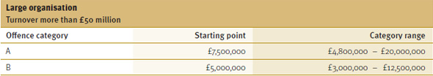
The sentencing exercise then mirrors that to be followed for health and safety offences, above.
Food safety and hygiene offences – Organisations and individuals
The Guideline covers a multitude of food safety and hygiene offences including placing unsafe food on the market, inadequate traceability, food recalls and withdrawals, failure to adopt systems based on HACCP principles and misleading consumers through labelling, advertising and presentation of food.
The approach to sentencing is the same as the health and safety offences with the same concepts of ‘culpability’ and ‘harm’. For individuals there is an increased possibility of custodial sentences for offences involving ‘very high’ or ‘high’ culpability. For large organisations the matrix is set out below:
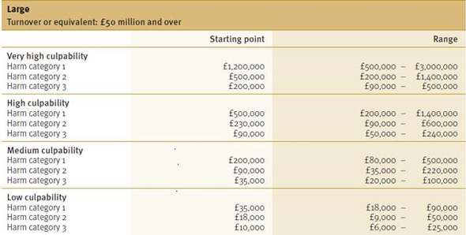
A key change in the Guideline is to the list of mitigating features which now excludes any evidence that the business or individual has effective food safety and hygiene procedures in place or evidence of any steps taken to remedy the problem. Therefore where a business may have fallen just short of establishing a due diligence defence; evidence of its systems and procedures will no longer be considered a mitigating feature.
The impact
The concept of imposing higher fines for serious health and safety offences and corporate manslaughter is not new. Sentencing guidelines were published a number of years ago but failed to have the impact expected. A suggested starting fine of £500,000 for corporate manslaughter offences has been rarely met. Some health and safety cases in more recent years have hinted towards increased fines, but the new Guideline represents a more joined up approach.
We expect the Guideline to increase the level of fines dramatically. Further, when sentencing, there will be significant work input by both the Prosecution and Defence when determining the correct levels of ‘harm’ and ‘culpability’. The difference between one harm category and another could be over £1 million and this is likely to have the following effects:
- Sentencing hearings will take longer and it may be necessary to undergo hearings to establish facts (‘Newton Hearings’) so that there can be evidence and legal arguments on the correct level of ‘harm’ and ‘culpability’;
- Expert evidence may be required, even for simple guilty pleas, in order to settle on the correct sentencing categories; and
- Organisation responses to regulator investigations may need to be more focused on mitigating the most serious sentencing categories.
Conclusion
The Guideline is arguably cynical; it is based on the premise that dutyholders will take health and safety and food safety more seriously if the penalties are higher. Those organisations that react to the Guideline and bring it to the attention of senior managers will most likely be those that have robust procedures. Those organisations that are ignorant of the Guideline will be in for an unwelcome surprise.

